Monitor an EC2 Instance
Task 1: Configure Amazon SNS
We first create the Topic
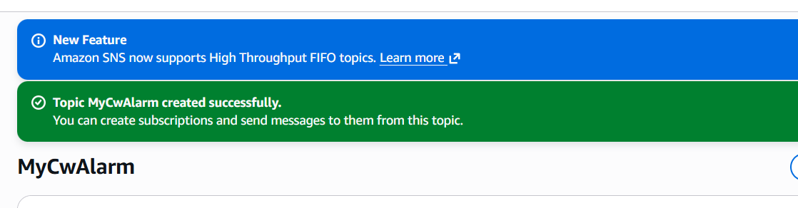
Next we create a subreption
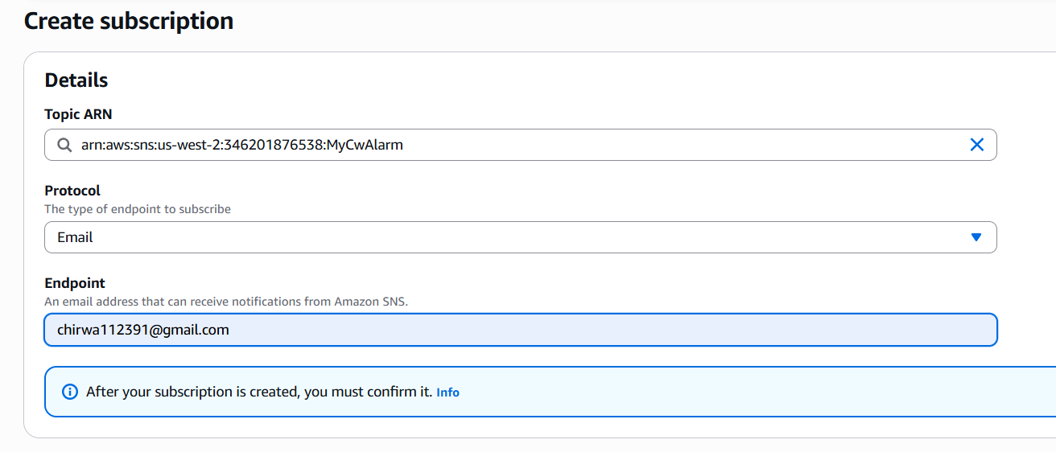
Subscription is created we need to confirm:
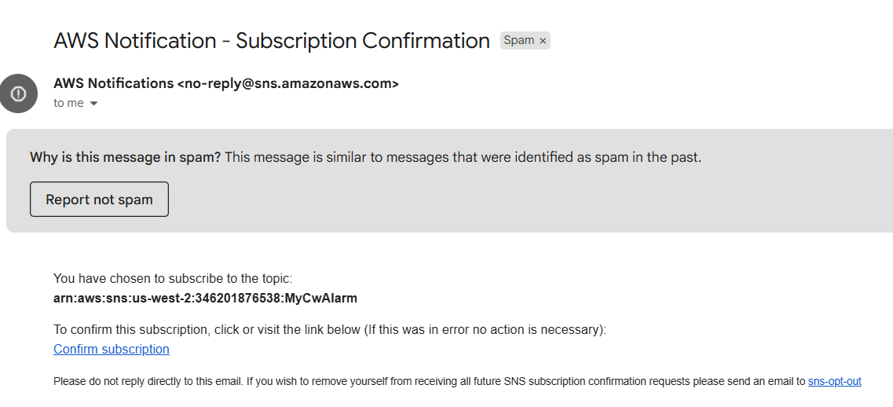
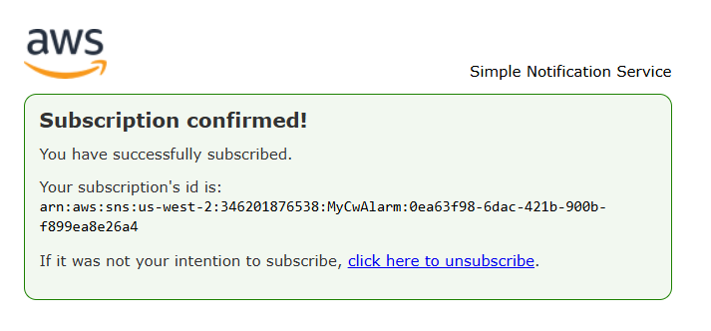
The Status should now be Confirmed.
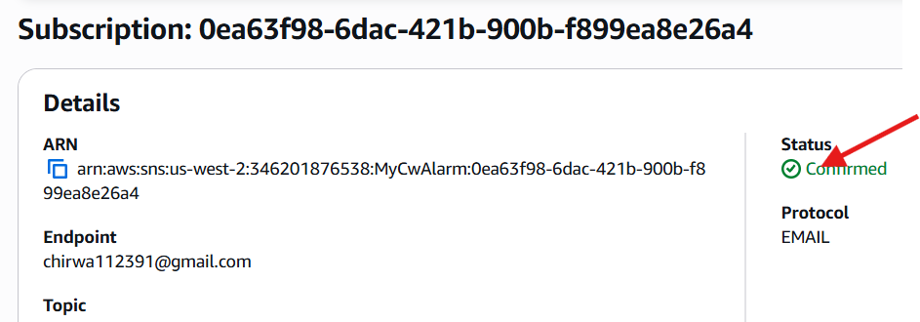
Task 2: Create a CloudWatch alarm
In this task, you view some metrics and logs stored within CloudWatch.
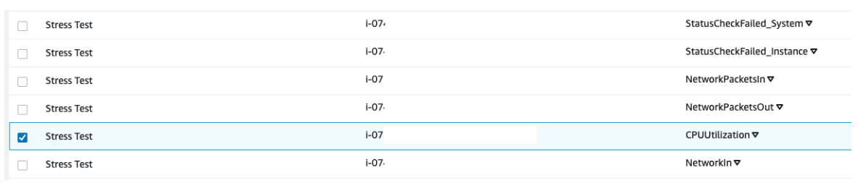
This option displays the graph for the CPU utilization metric, which should be approximately 0 because nothing has been done yet.
Next we create the metric alarm:
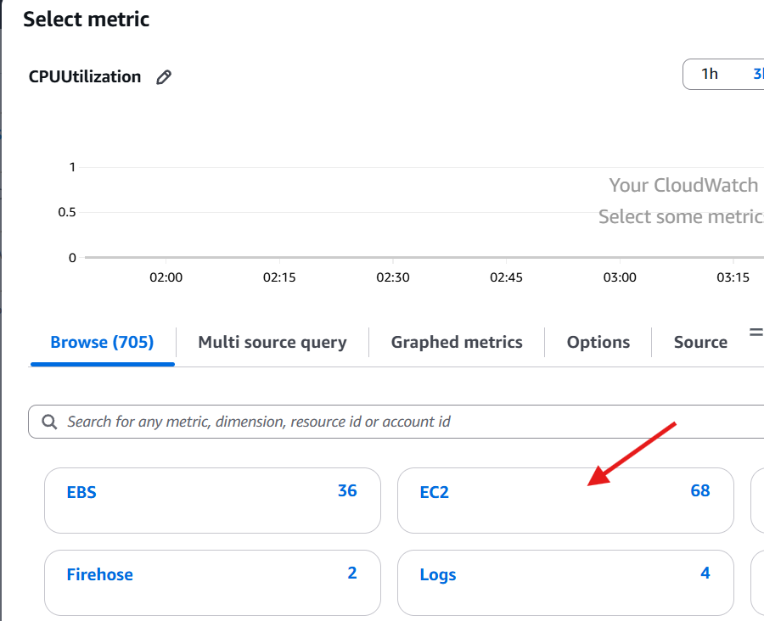
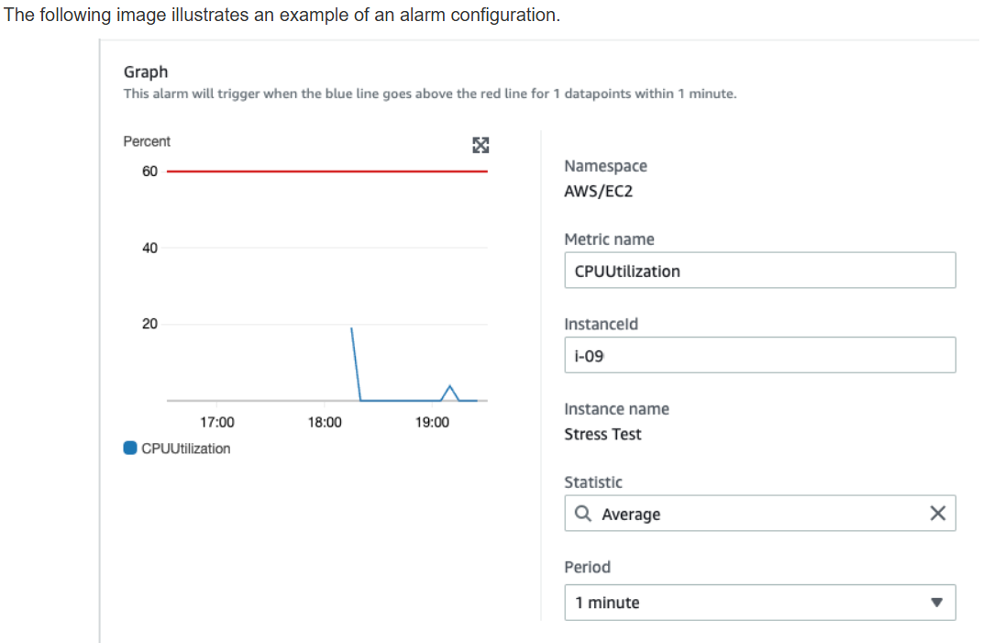
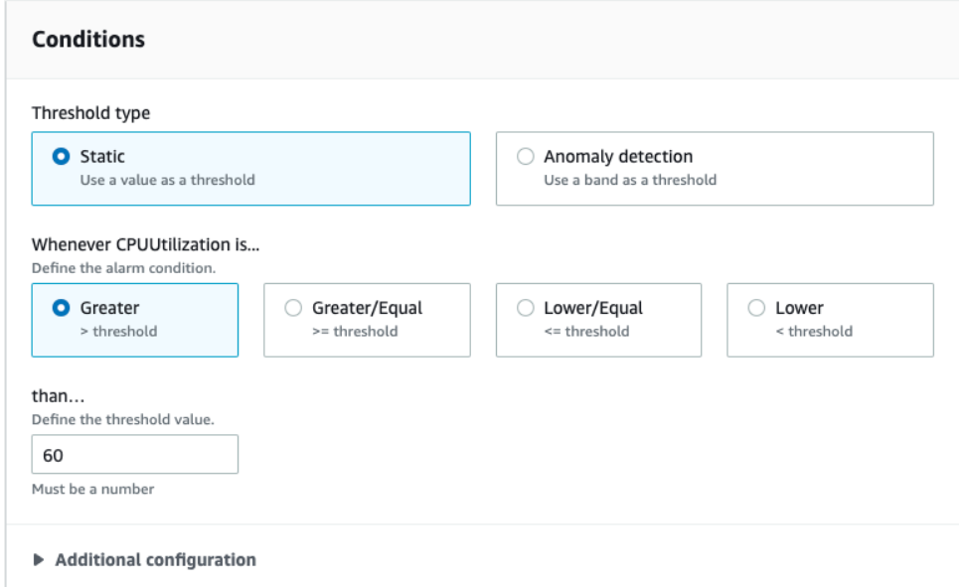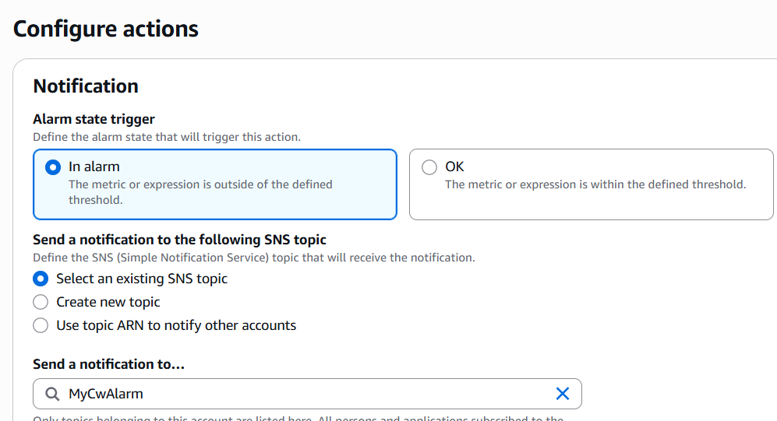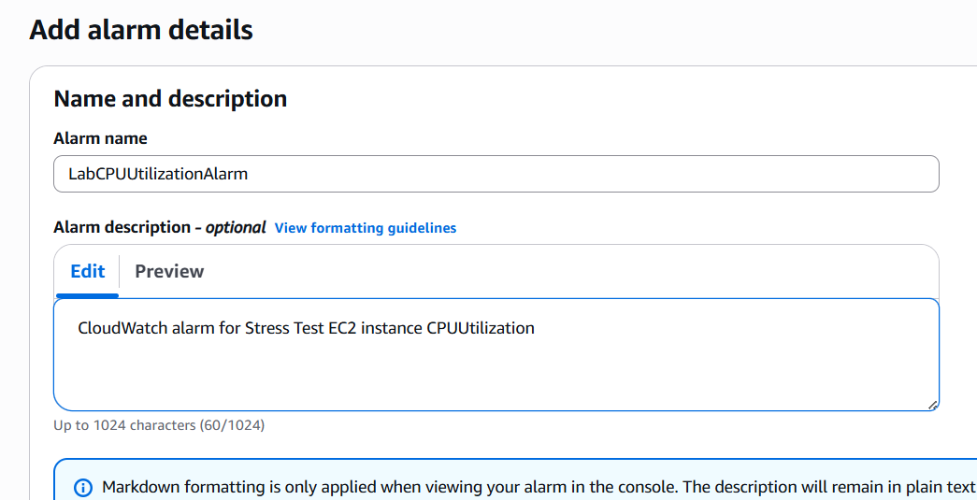
Task 3: Test the Cloudwatch alarm
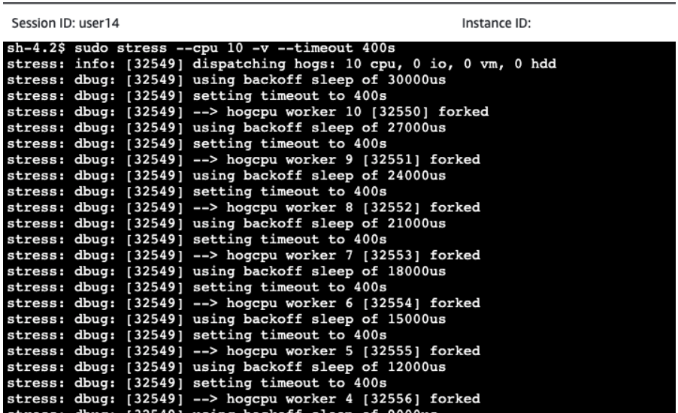
This command runs for 400 seconds, loads the CPU to 100 percent, and then decreases the CPU to 0 percent after the allotted time.
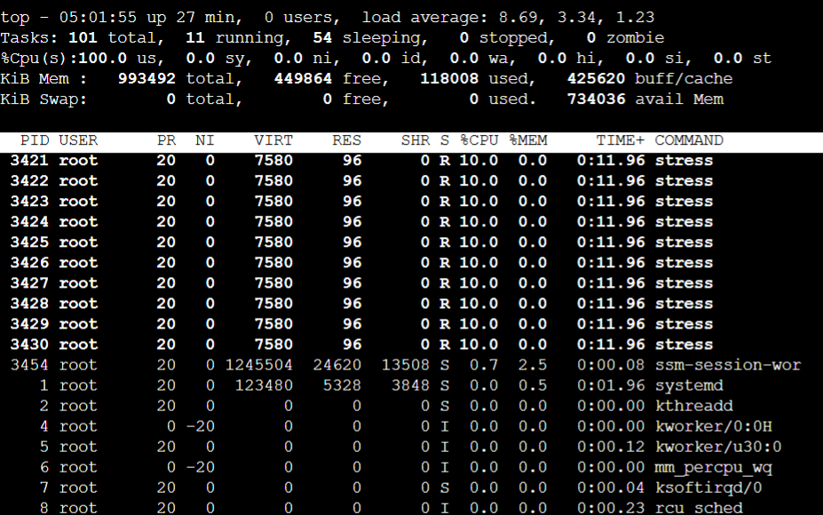
This shows the live usage of the CPU.
Task 4: Create a CloudWatch dashboard
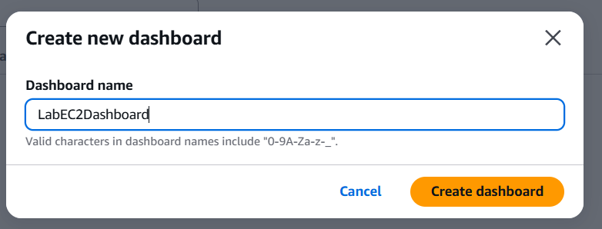
Now you have created a quick access shortcut to view the CPUUtilization metric for the Stress Test instance.
